Assignment on Serverless Architecture &amp; Cloud Automation

Assignment 1: Automated Instance Management Using AWS Lambda and Boto3
- Created two Ec2 instances and tagged them as Auto-stop and Auto-start, I mentioned as jsree for my own reference.

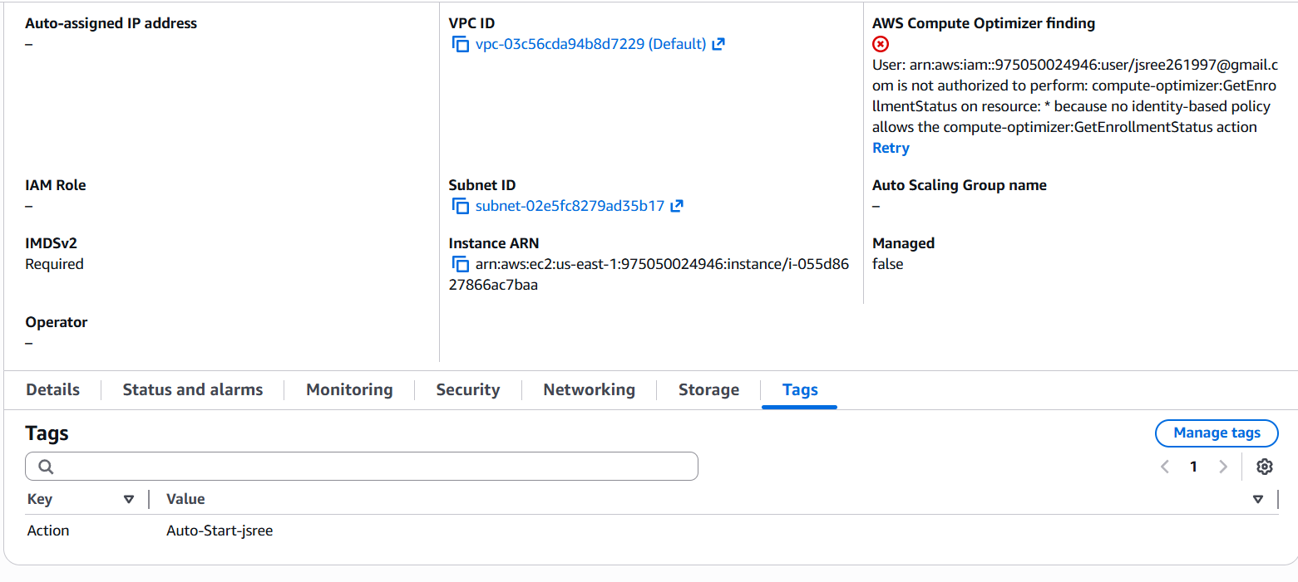
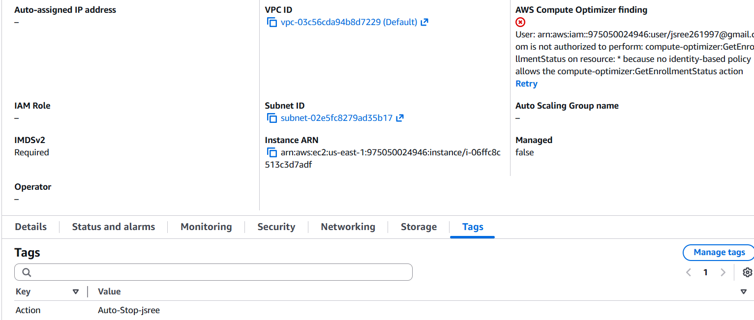
- Created the IAM role for Lambda function
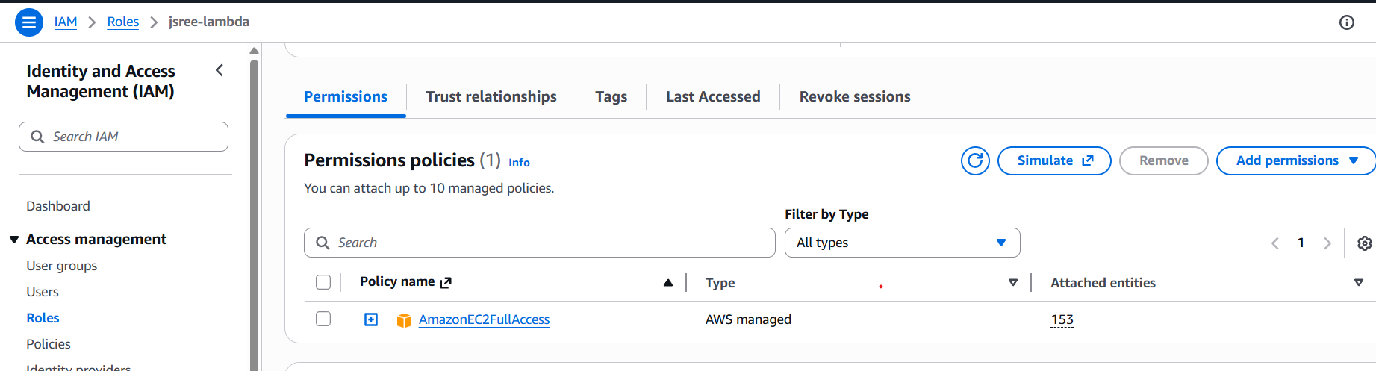
This policy gives full access to the Ec2
- Created a lambda function and imported the python code, which turns the Ec2 ON and OFF using the tags.

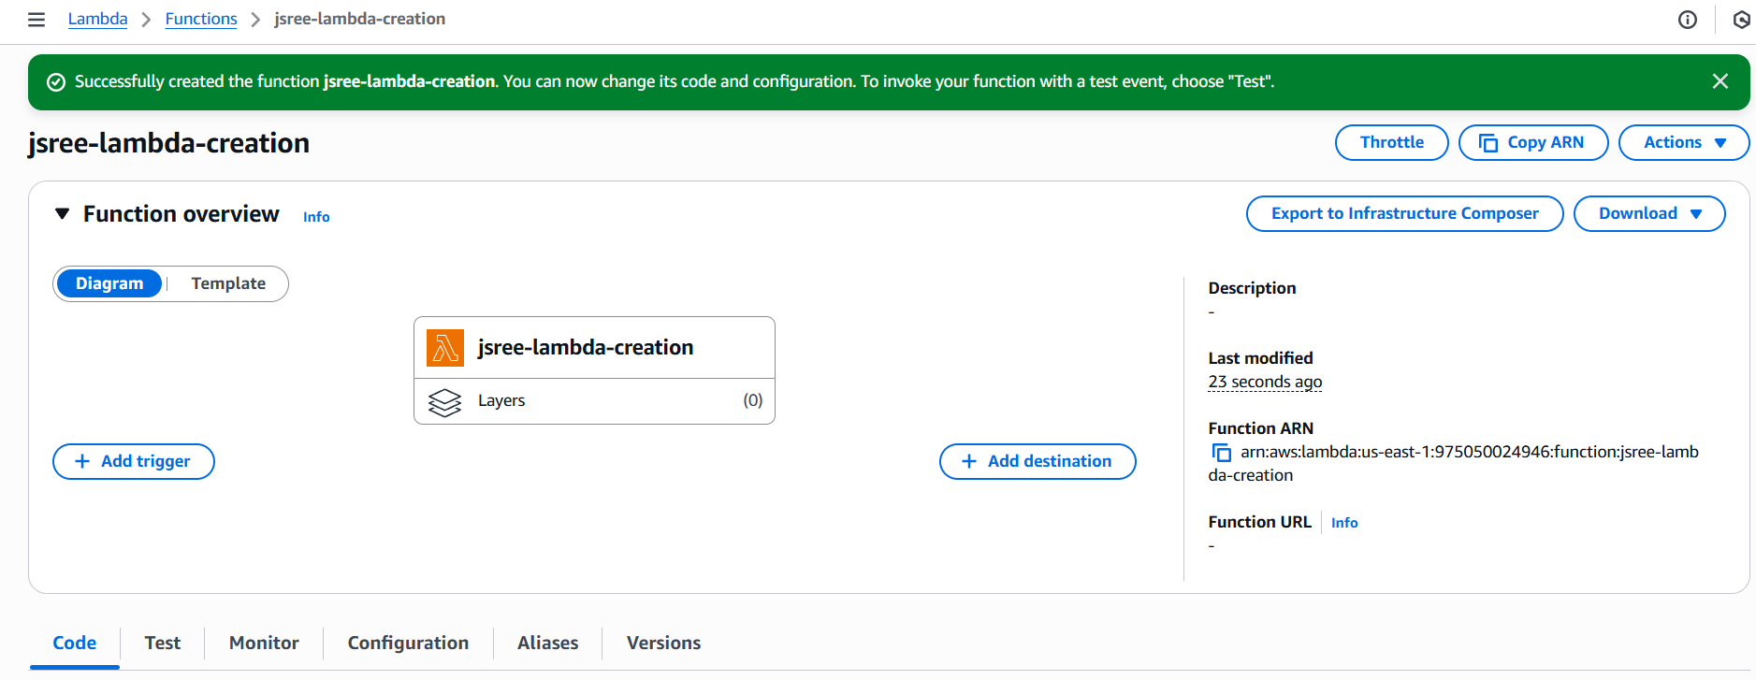

- Triggered the test, the below output shows the same

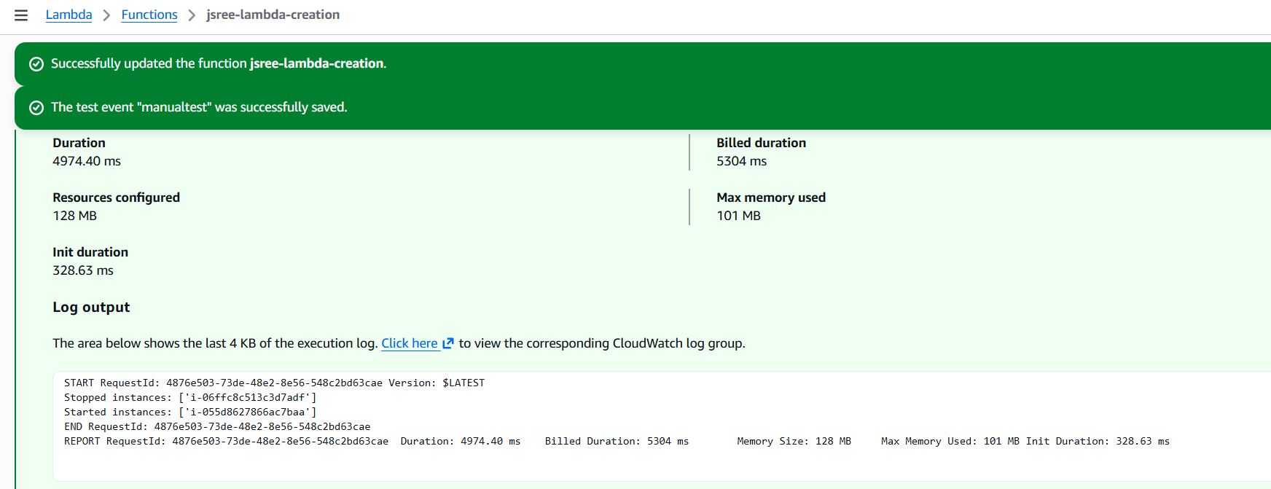

Assignment 2: Automated S3 Bucket Cleanup Using AWS Lambda and Boto3

When I tried to manually adjust the system time temporarily and then upload a file to the S3 bucket, the upload was not successful and an error was raised.
Therefore, I modified the code so that one of the files in the bucket is treated as if it were 30 days old, and that specific file gets deleted automatically.

I uploaded two files to the bucket named Test 1.doc and Test 2.doc. I made the Test 2.doc file appear 30 days older and deleted it. For this, I created an IAM role for the Lambda function.

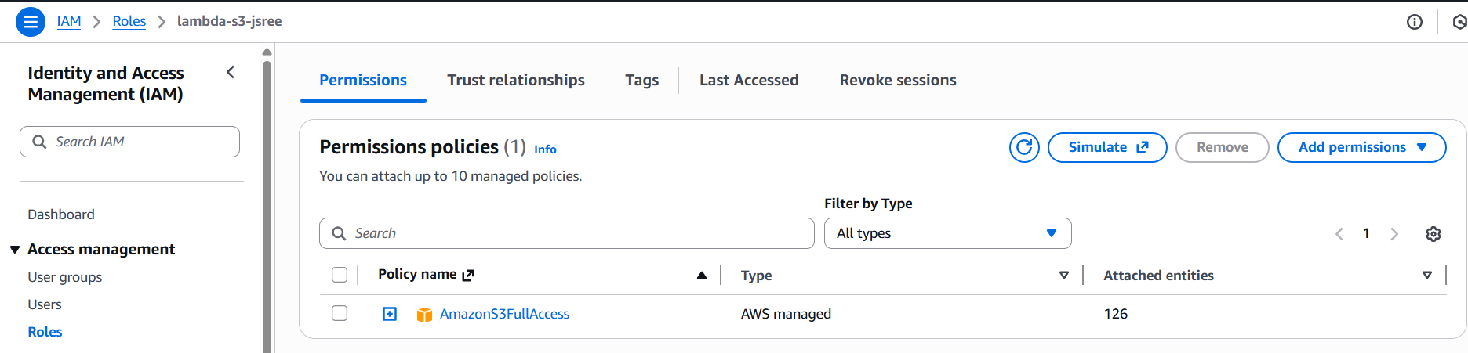

Created a lambda function

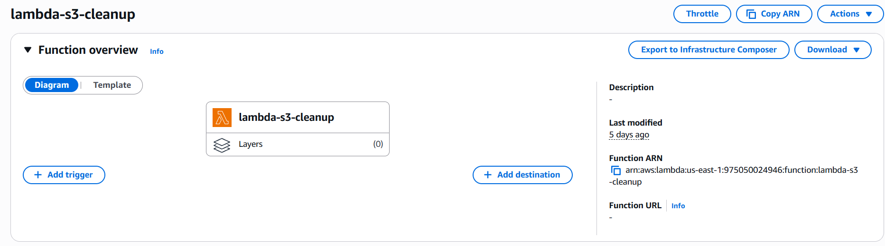

Output:
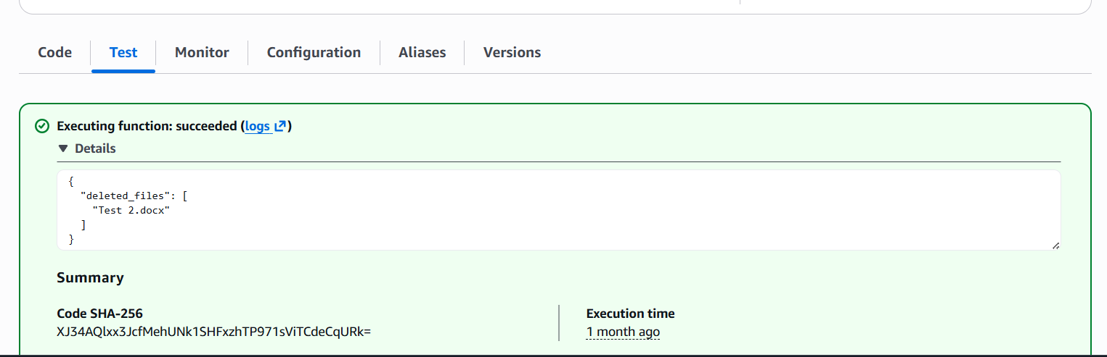

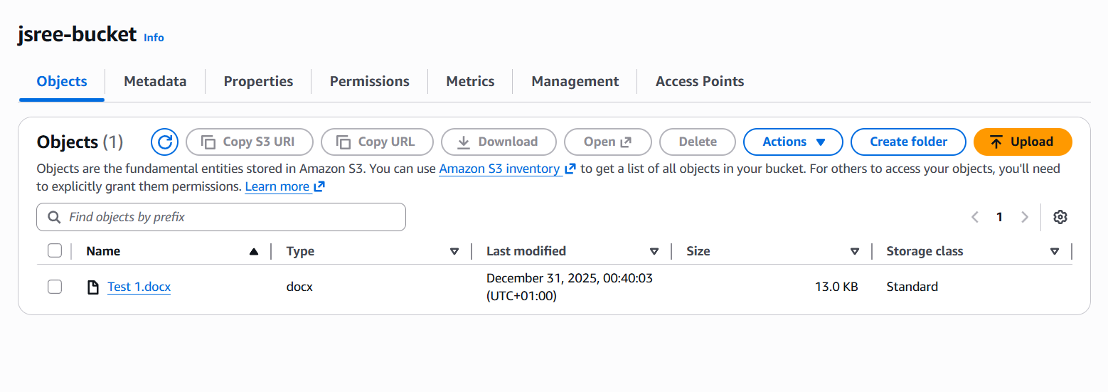

Assignment 3: Monitor Unencrypted S3 Buckets Using AWS Lambda and Boto3

In the S3 console, default encryption could not be disabled because AWS enforces server-side encryption by default for new buckets. For the purpose of this assignment, buckets were created without explicitly configuring encryption earlier, allowing the Lambda function to detect buckets without an encryption configuration using the get_bucket_encryption() API call.

Created the buckets

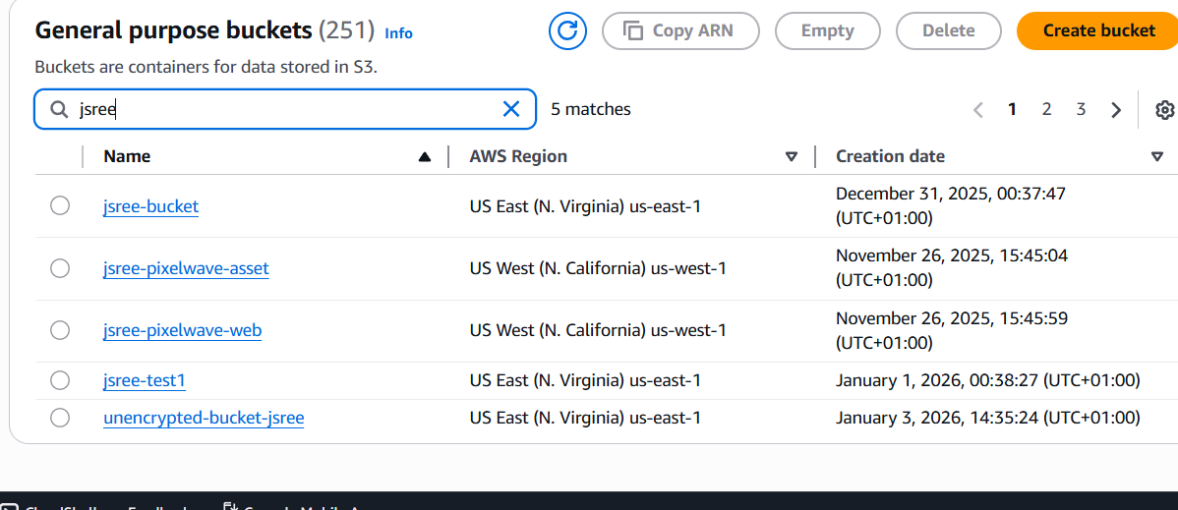

IAM role for lambda function

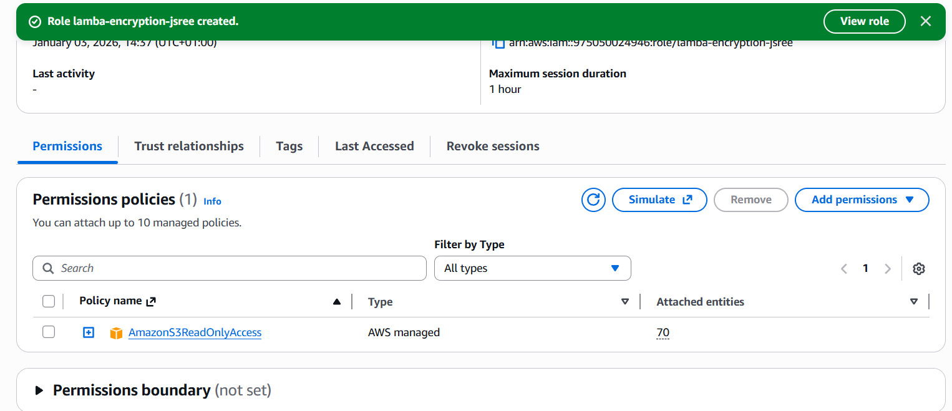

Creation of lambda function

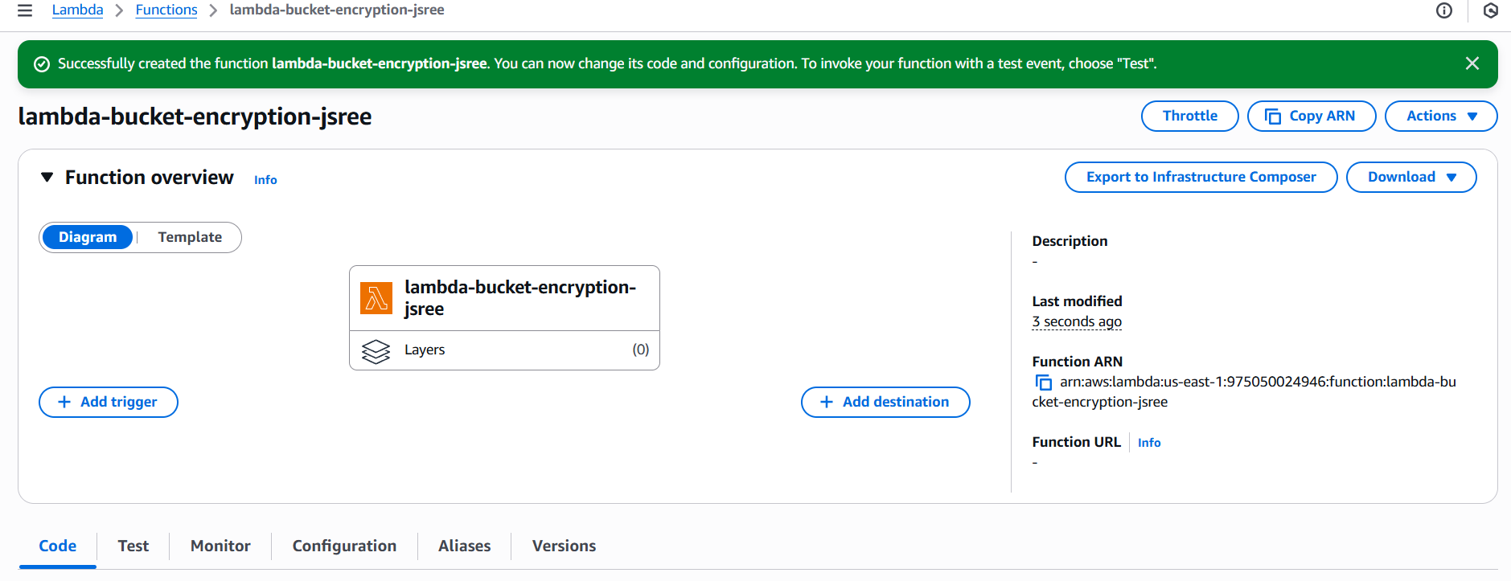

Output:

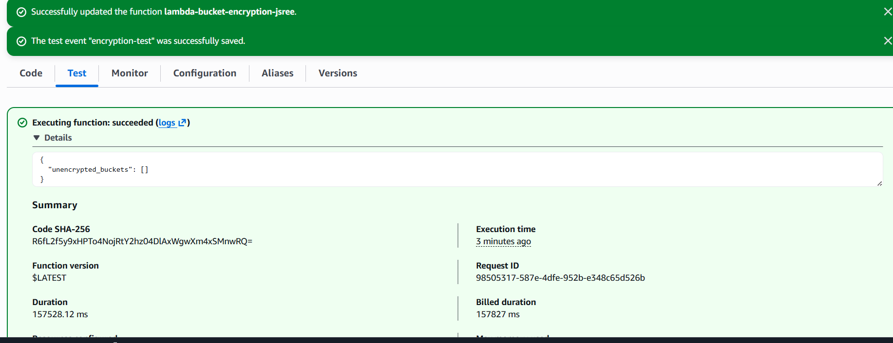

From the output, we could see that, no bucket is found without encryption.

Assignment 4: Automatic EBS Snapshot and Cleanup Using AWS Lambda and Boto3

Created a EC2 instanced and attached a volume to it. To backup that volume, first found the volume ID of it.

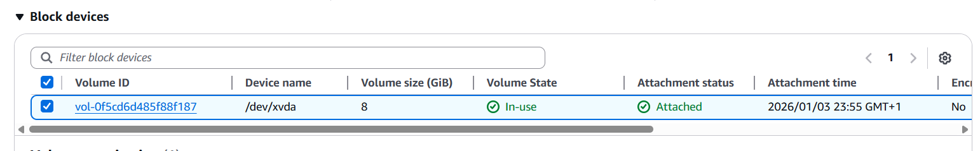

Then created the IAM role for the lambda function

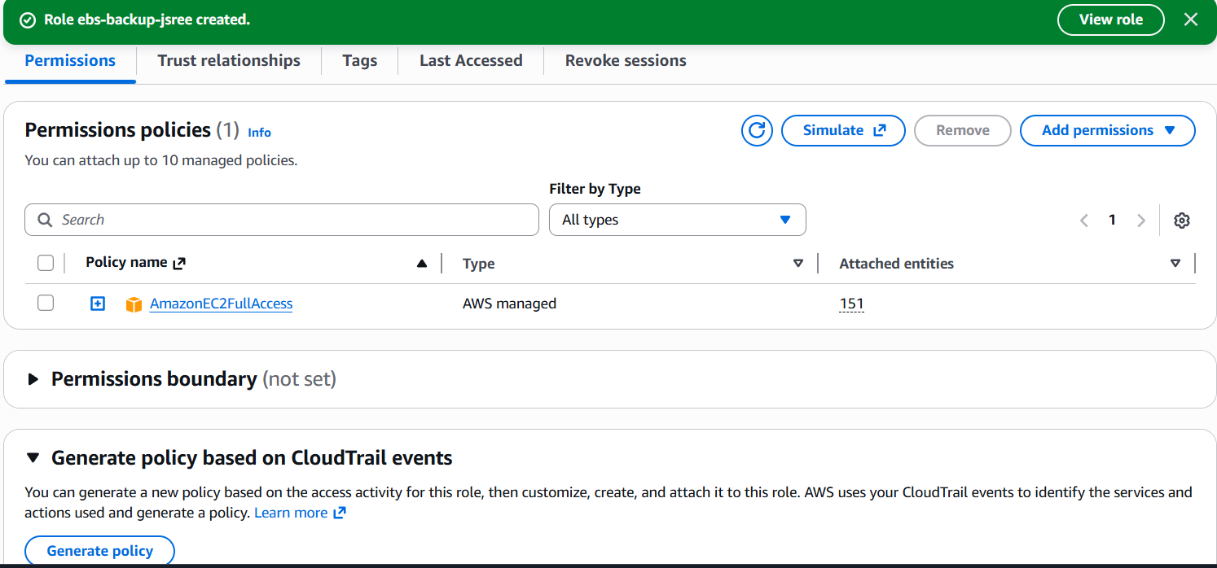

Created the lambda function

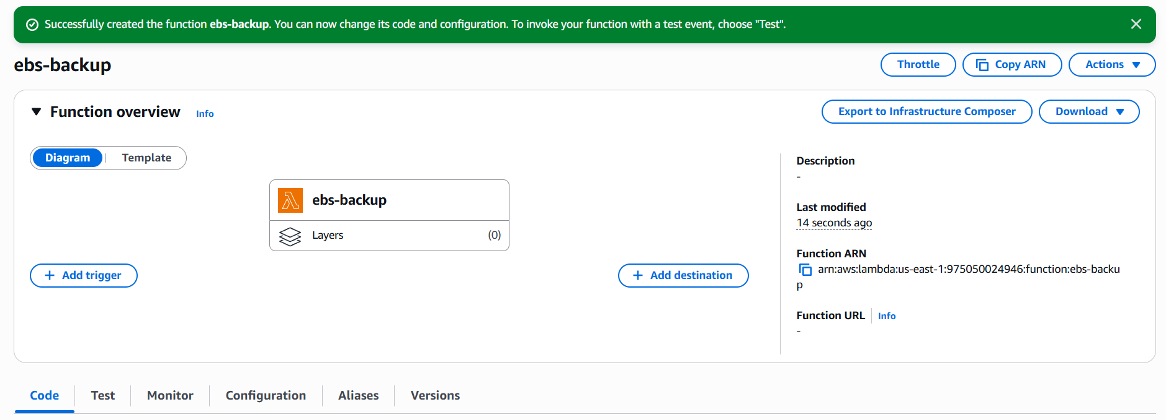

Output:

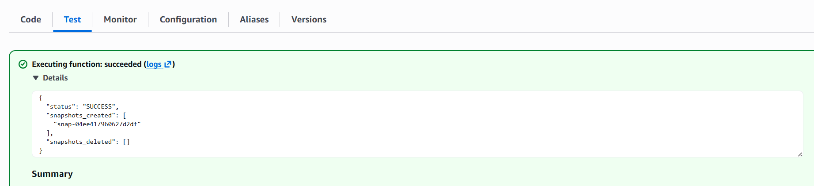

The snapshot was created for the respective volume, and no snapshots were deleted because there were no snapshots older than 30 days.

Created a EventBridge to schedule the lambda function to run on very Sundays

